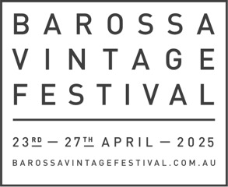FRIENDS OF THE BAROSSA

VINTAGE FESTIVAL 2025

REGISTRATION FORM

|  |  |  |  |  |  |  |  |  |  |  |  |  |  |
| --- | --- | --- | --- | --- | --- | --- | --- | --- | --- | --- | --- | --- | --- |
| FIRST NAME: |  | | | | SURNAME: | | | |  | | | | |
| ADDRESS | STREET: | |  | | | | | | | | | | |
|  | TOWN : | |  | | | | | | | | | POSTCODE: | |
| PHONE NO. |  | | | | | | | | | | | | |
| EMAIL ADDRESS | |  | | | | | | | | | | | |
| LISTING NAME FOR YOUR FRIENDS REGISTRATION (BUSINESS NAME/OWN NAME?) | | | | | | | | | | | | | |
|  | | | | | | | | | | | | | |
| FRIENDS LEVEL | | PLATINUM ($1500) | | | | GOLD ($1000) | | | | | | SILVER ($500) | |
| **PAYMENT PREFERENCES** | | | | | | | | | | | | | |
| 1 INSTALMENT | | | | 2 INSTALMENTS | | | | | | 3 INSTALMENTS (PLATINUM ONLY) | | | |
| INVOICE | |  | | | | CREDIT CARD | | | | |  | | |
| INVOICE NAME: | |  | | | | NAME ON CARD: | | | | |  | | |
|  | | | | | |  | | | | | | | |
| ADDRESS: | |  | | | | CREDITCARD NUMBER: | | | | |  | | |
|  | | | | | |  | | | | |  | | |
|  | | | | | | EXP DATE:       / | | | | | | | CVV: |
|  | | | | | |  | | | | |  | | |
| SIGNATURE: | |  | | | |  | | | | |  | | |
| DATE:       /      / 2024 | | | | | | |  |  | | |  | | |

Email to [director@barossavintagefestival.com.au](mailto:director@barossavintagefestival.com.au)